**COVID VACCINES ANALYSIS**

**PHASE-4**

**Exploratory Data Analysis (EDA):**

EDA is crucial to understand your data before diving into statistical analysis and visualization. In this case, you'll likely be working with datasets containing information about COVID-19 vaccination rates, types of vaccines, and other relevant variables. Python libraries such as pandas, numpy, and seaborn will be useful for EDA.

Import necessary libraries:

import pandas as pd

import numpy as np

import seaborn as sns

import matplotlib.pyplot as plt

Load your data:

COMMAND:

data = pd.read_csv("/content/country_vaccinations.csv ")

data = pd.read_csv("/content/country_vaccinations_by_manufacturer.csv ")  
  
OUTPUT:

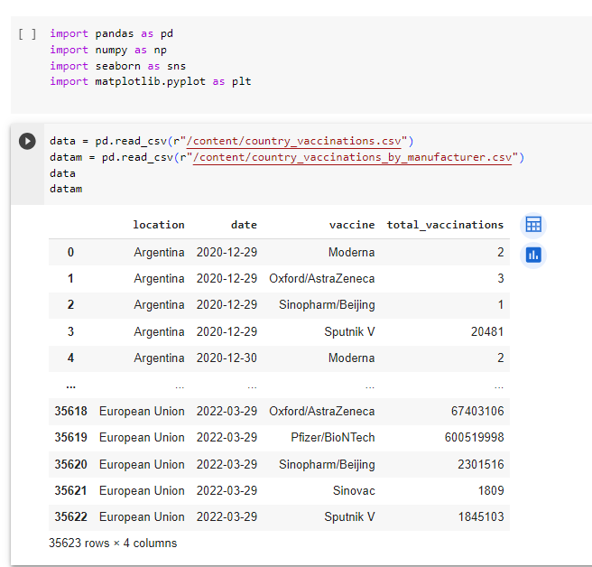

**BASIC DATA EXPLORATION:**

COMMANDS:

Use to show the first few rows of the given dataset.

print(data.head())

OUTPUT:

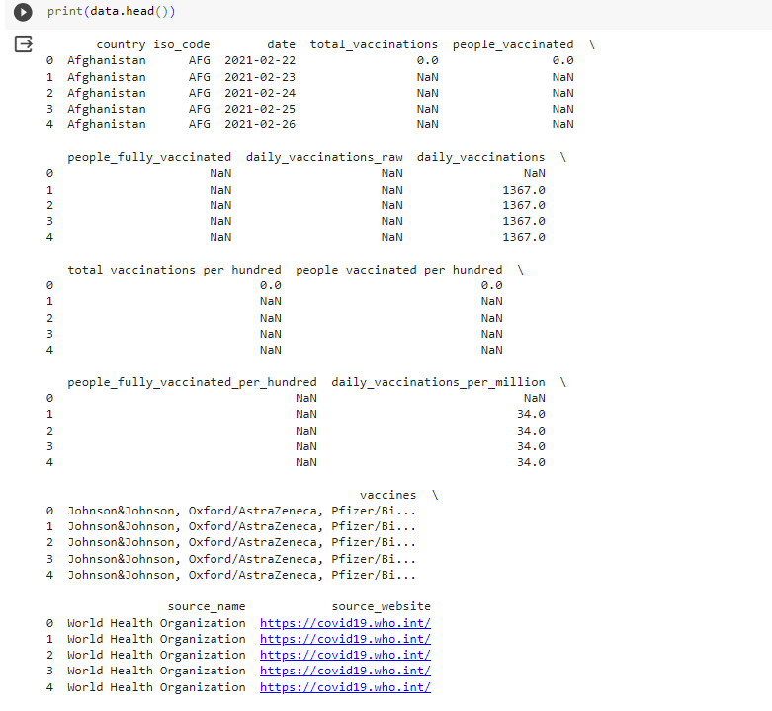

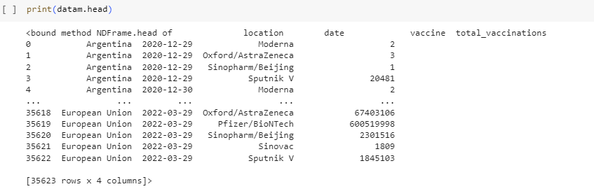

Use to get summary statistics.

print(data.describe())

OUTPUT:

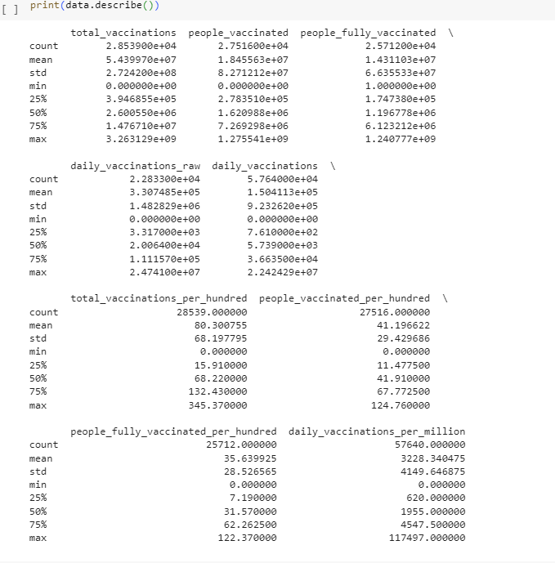

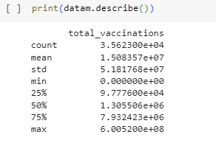

Use to check the missing values.

print(data.isnull().sum())

OUTPUT:

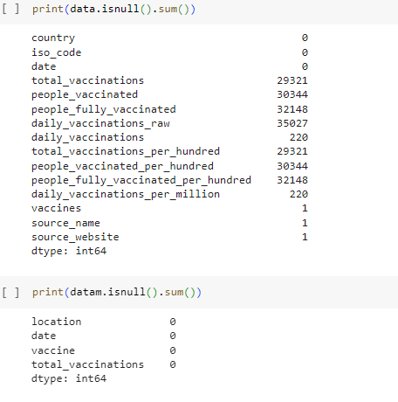

Use to explore unique values in categorical columns.

print(data['vaccines'].value_counts())

OUTPUT:

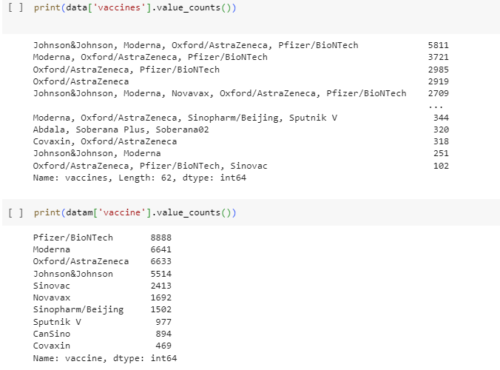

**STATISTICAL ANALYSIS:**

Depending on your research questions, you can perform statistical tests and calculations to draw insights. For instance, you can compare vaccine effectiveness, distribution of vaccines across regions, or calculate vaccination rates.

Calculate vaccination rates:

COMMAND:

data['vaccination_rate'] = (data['people_vaccinated /data['total_vaccinations']) * 100

mean_vacc_rate = data['vaccination_rate'].mean()

mean_vacc_rate

std_vacc_rate = data['vaccination_rate'].std()

std_vacc_rate

print("Mean Vaccination Rate:", mean_vacc_rate)

print("Standard Deviation of Vaccination Rate:", std_vacc_rate)

OUTPUT:

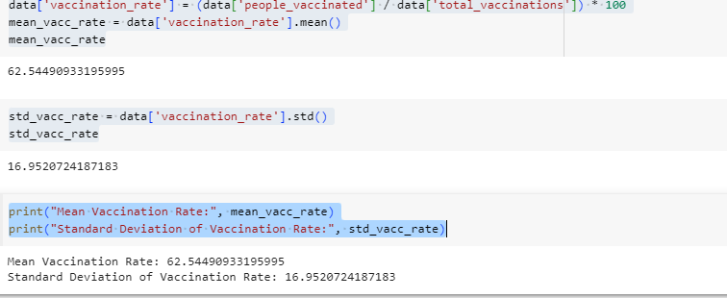

VISUALIZATION:

Visualizations help in communicating your findings effectively. Libraries like matplotlib and seaborn can be used for creating various types of plots.

* Create bar plots for vaccine distribution,

COMMANDS:

plt.figure(figsize=(10, 6)) sns.countplot(data=data, x='vaccines') plt.title("COVID-19 Vaccine Distribution") plt.xticks(rotation=45) plt.show()

OUTPUT:

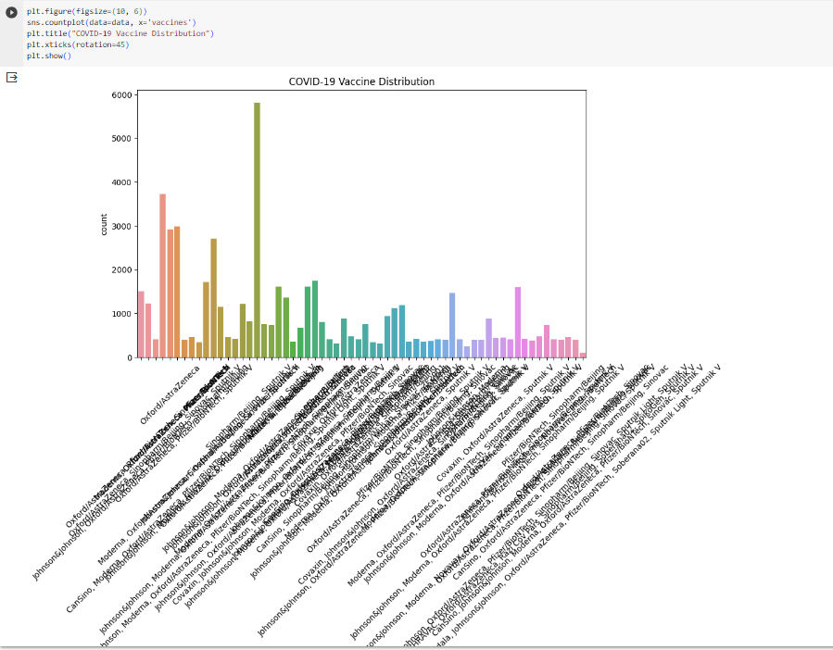

Create a histogram of vaccination rates:

COMMANDS:

plt.figure(figsize=(8, 6))

sns.histplot(data=data, x='vaccination_rate', bins=20, kde=True)

plt.title("Distribution of Vaccination Rates")

plt.xlabel("Vaccination Rate (%)")

plt.ylabel("Frequency")

plt.show()

OUTPUT:

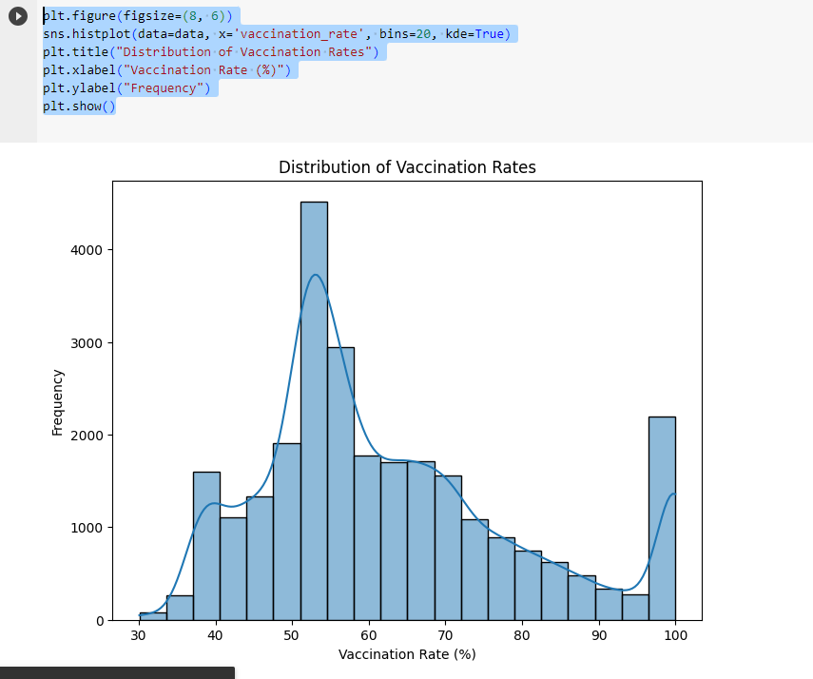

)

* Create geographic visualizations: You can use geospatial libraries like Folium or Plotly to create maps showing vaccination rates by region.

Remember to customize these analyses and visualizations to suit your specific research questions and dataset. It's important to clean and preprocess your data as needed and choose the appropriate statistical tests for your hypotheses. Also, ensure that you have the required datasets available before performing the analysis.